Hiring a cat sitter
You need to go away for an unknown number of days. Your two cats would be
left alone for the entire time, so you need to hire a cat sitter. Design a
program that will calculate the total price of the sitter based on the following
criteria:
$50 per day
Distance from office to your house
If less than 2 KM, free travel
if 2-5 KM, $5 per trip
If 5-10 KM, $10 per trip
If greater than 10KM, $15 per trip
Tip (input as a percentage on the final total)
DISPOSITION
Calculate cost per day (input number of days)
- Return Number of days * 50
Calculate cost of travel (input the distance to travel, number of days)
- If less than 2 KM, free travel
- if 2-5 KM, $5 per trip
- If 5-10 KM, $10 per trip
- If greater than 10KM, $15 per trip
- Return calculated cost
Calculate tip (input total cost)
- Return total cost * tip rate
Main program
- Input days
- Calculate cost per day
- Calculate cost of travel
- Calculate tip
- Output Final cost

FLOWCHART
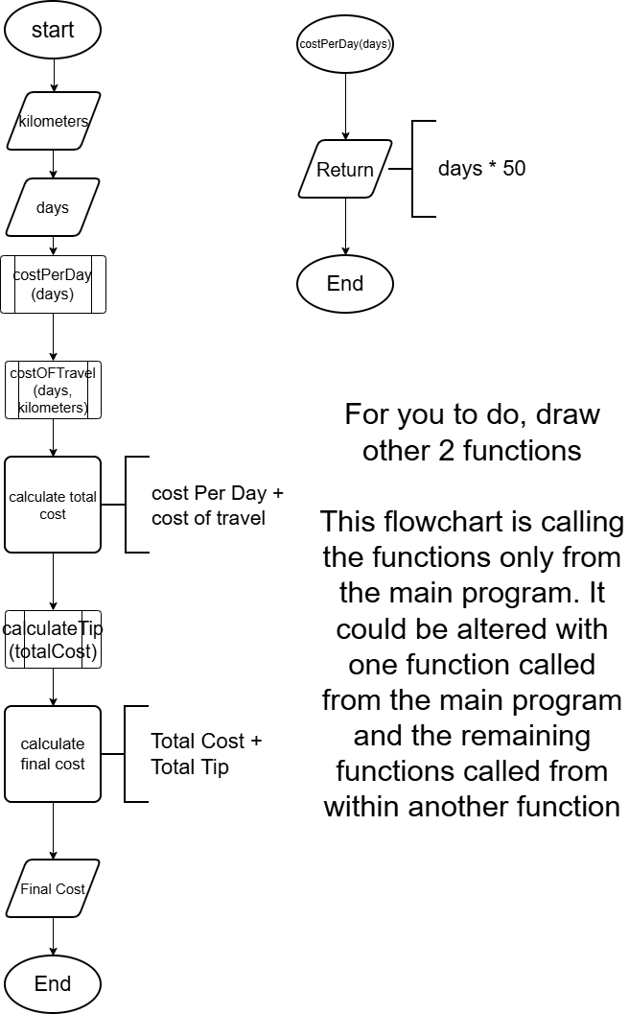

Using PseudoCode
FUNCTION costPerDay(days)
RETURN days * 50;
ENDFUNCTION
FUNCTION costOfTravel(days, kilometers)
DELCARE travelCost = 0
IF (Kilometer <= 2) THEN
SET travelCost = 0
ELSEIF (Kilometer <= 5)
SET travelCost = days * 5
ELSEIF (Kilometer <= 10)
SET travelCost = days * 10
ELSE
SET travelCost = days * 15
ENDIF
RETURN travelCost
ENDFUNCTION
FUNCTION calculateFinalCost(days, kilometers)
DECLARE dayCost
DELCARE travelCost
DECLARE tipRate = 18 /100
//demonstrating a function can call another function
SET dayCost = FUNCTION costPerDay(days)
SET travelCost = FUNCTION costOfTravel(days, kilometers)
RETURN tipRate * (dayCost + travelCost)
ENDFUNCTION

//Main Program
START
DELCARE FinalCost
INPUT days
INPUT kilometres
SET FinalCost = calcalateFinalCost(days, kilometers)
PRINT FinalCost
END

